[DCO-2455] Motive Financial - Authenticated Signers Functional accessibility issues with "Next/Call" controls Created: 01/May/24 Updated: 06/May/24
Status: | In External Review
Project: | Journey Manager
Components: | None
Affects versions: | None
Fix versions: | Accessibility

Type: | Story | Priority: | None
Reporter: | Sanya Khandhuja | Assignee: | Fusi Olateru
Resolution: | Unresolved | Votes: | 0
Labels: | Motive, MotiveAuthenticated
Remaining Estimate: | Not Specified
Time Spent: | Not Specified
Original estimate: | Not Specified

Attachments: | image-20240501-133141.png image-20240501-133206.png
QA Bug Count: | 0
Days Open: | 5 days
Bug Count: | 0
Hours Variance: | 0
Hours Remaining: | 0
Hours Target PMO: | 0
Sprint:
Days Open: | 5

Description

Functional accessibility issue: The “Next / Call” controls within the two factor authentication setup fail to adequately distinguish focus. The control when in focus removes the underline under the button text with no additional focus indication.
Examples:
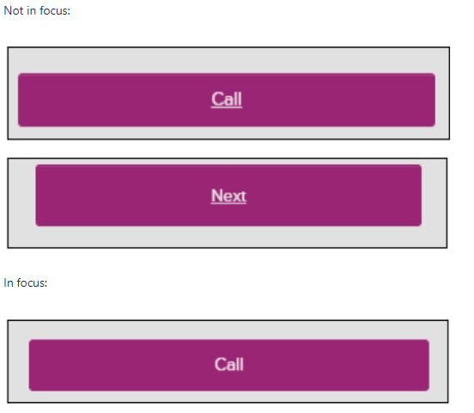

■ Recommendation: Add a far stronger visible focus indicator (such as an outline around the control) in order to reinforce that the user has given the control focus.
Generated at Wed May 08 16:13:37 UTC 2024 by Ian Hicks using Jira 1001.0.0-SNAPSHOT#100252-rev:001dd3b46b0e2bd1b1649b341ae80995ab509a2b.

